Communication between containers on same host

Step1 : check the networks that exists in your docker environment
docker network ls
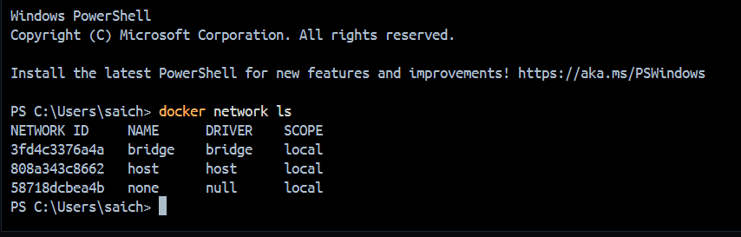

Step2 : Create two containers using prebuilt images, Commands
docker run -d --name container1 nginx
docker run -d --name container2 nginx
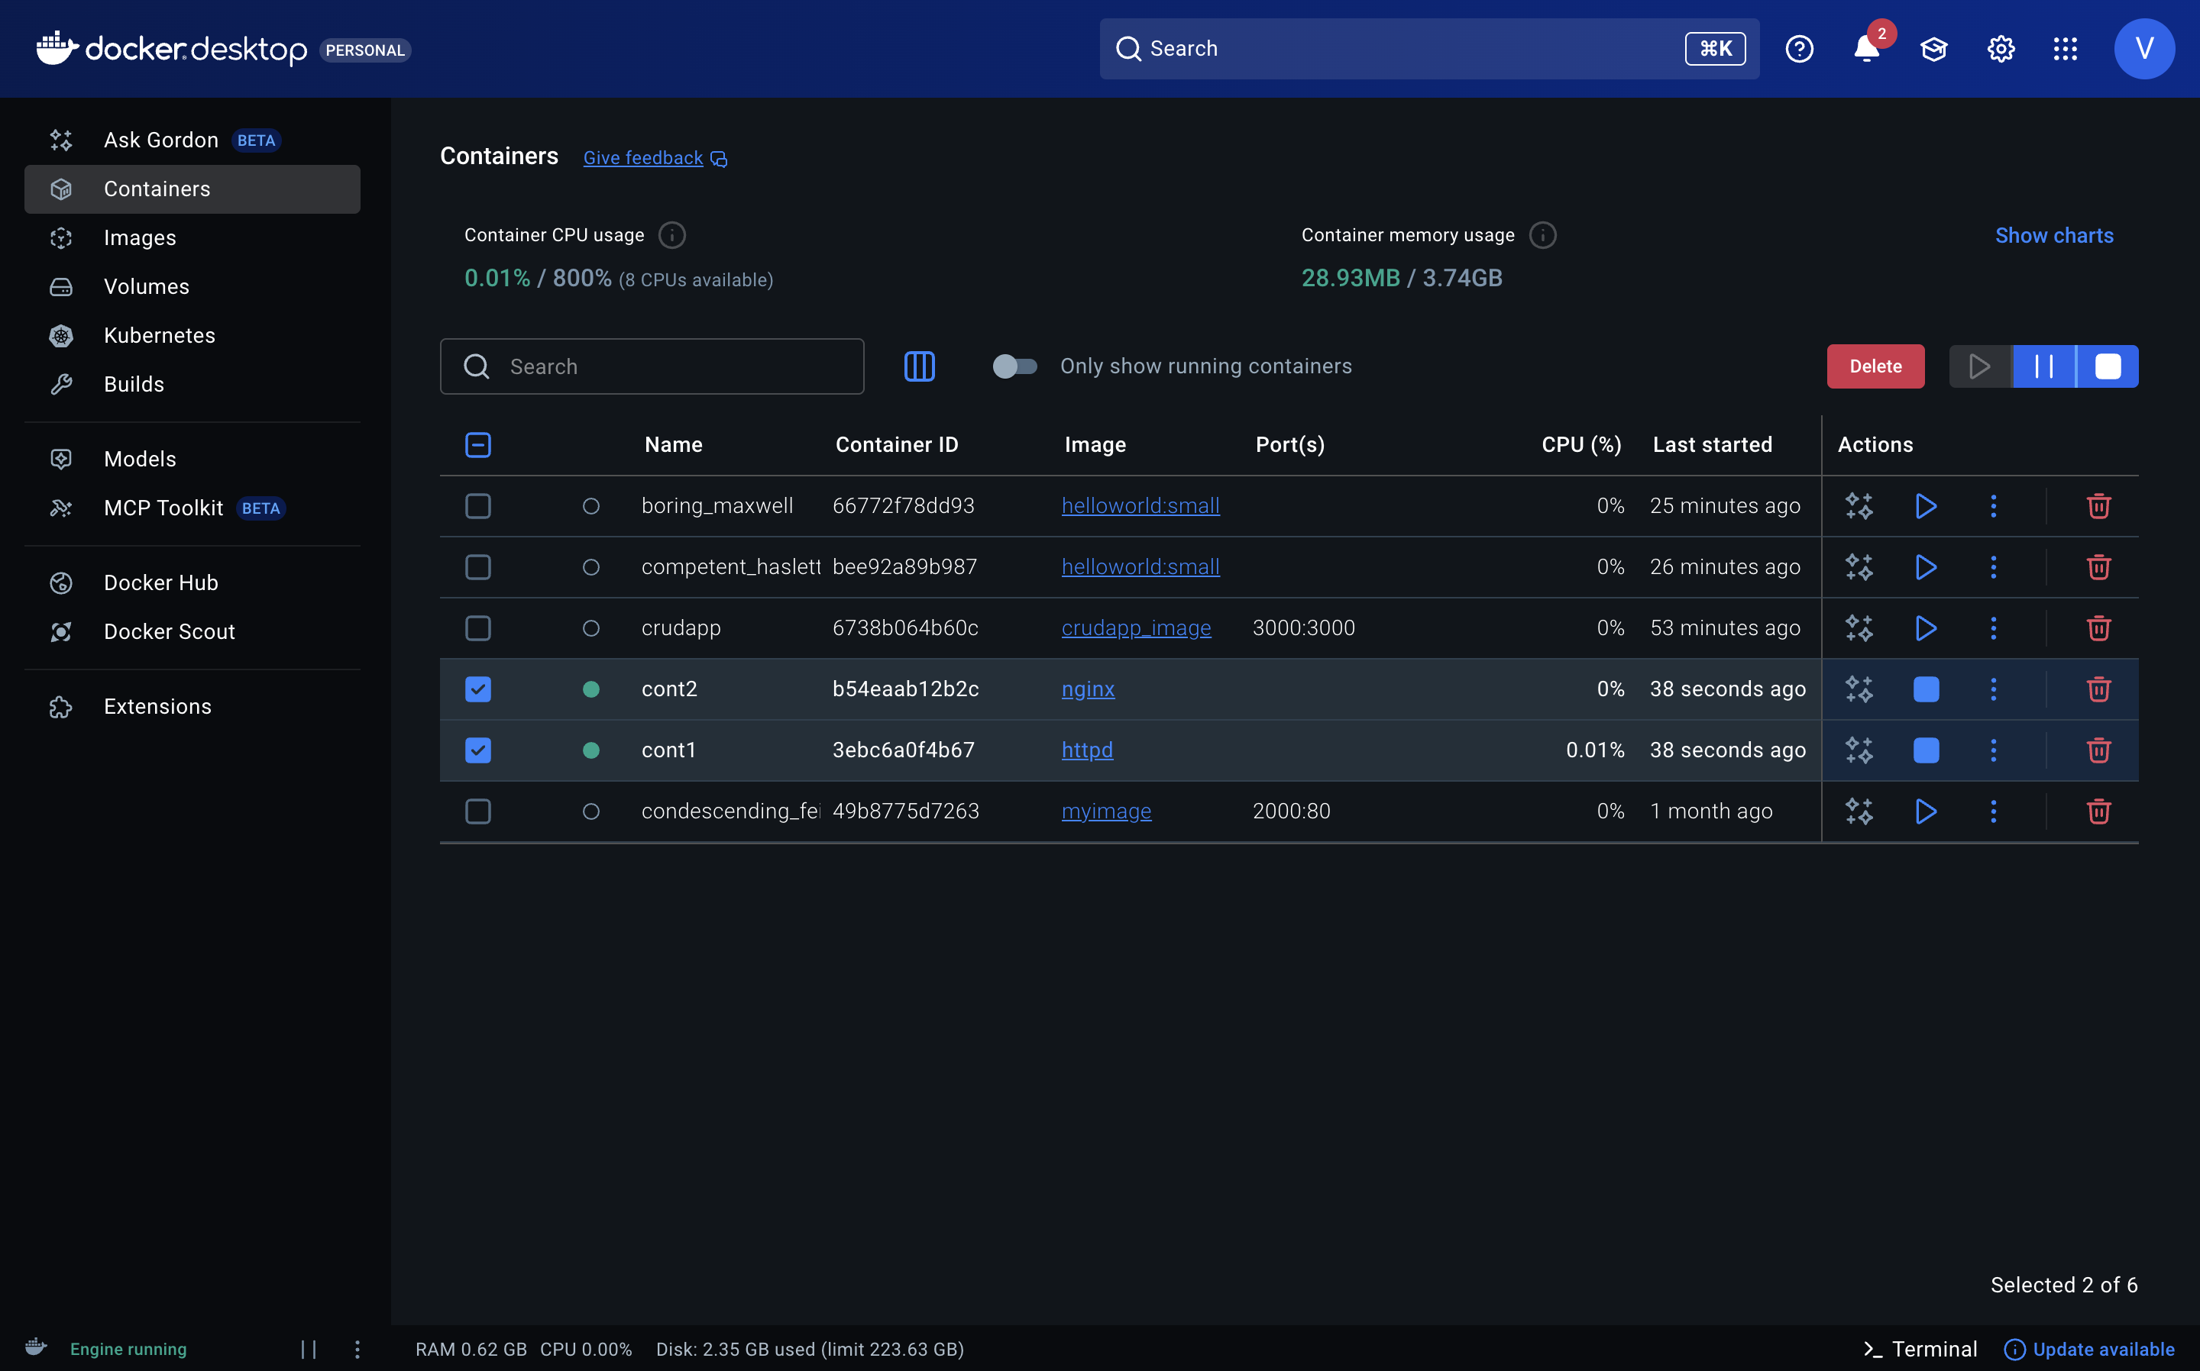
Step 3 : list all the containers on your system, including those that are currently running, stopped, or exited
docker ps -a
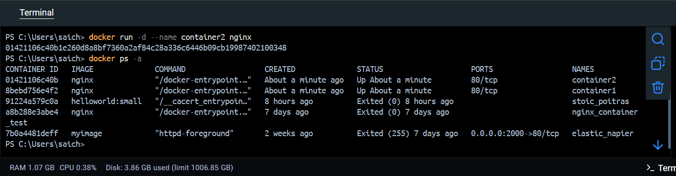

Steps to Create a Network and Ping a Container

1.Create a Docker Network: You can create a bridge network using the following command :
docker network create --driver bridge mynetwork
**check the networks that exists in your docker environment
command - docker network ls
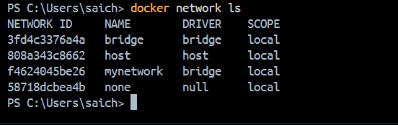

2. now connect the two containers to network
docker network connect mynetwork container1
docker network connect mynetwork container2
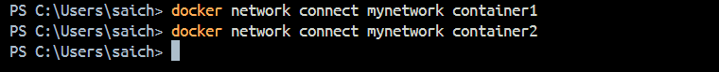

3. Check whether containers are connected to network or not
Command – docker inspect <resource_id>
example- docker inspect mynetwork or use id of network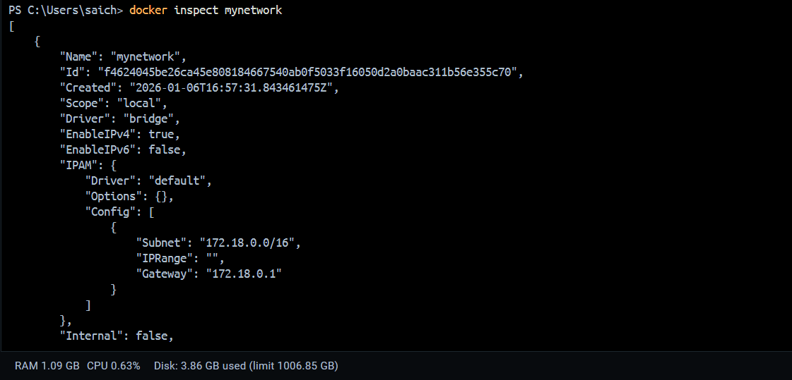 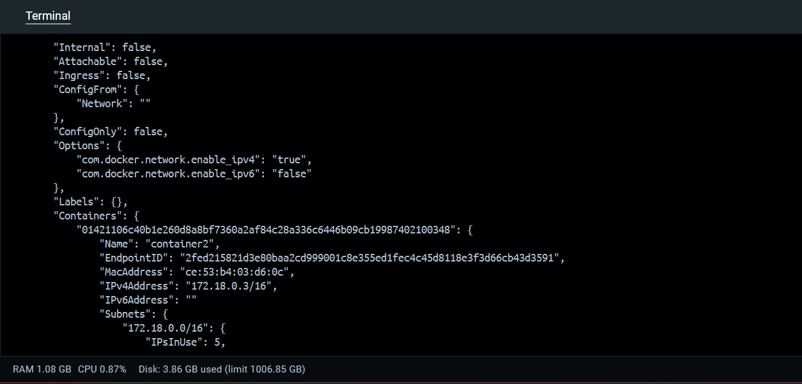 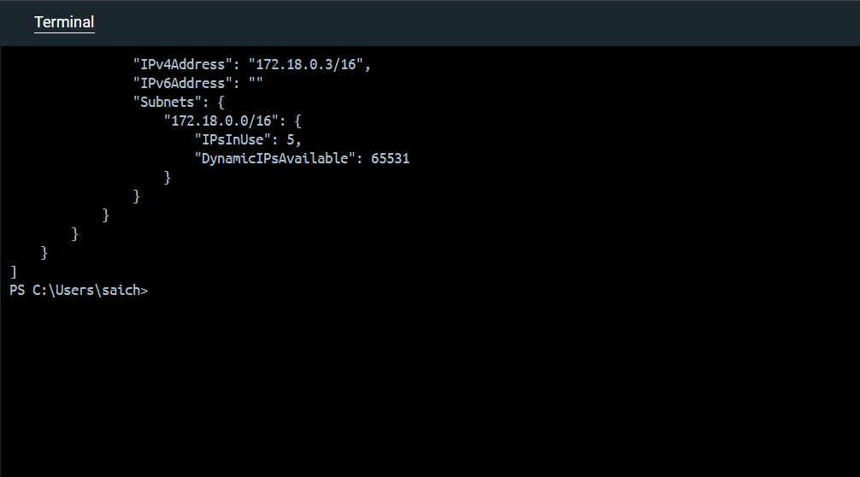

4. execute an interactive bash shell inside a running Docker container named container1
Command – docker exec -it container1 bash

Your project folder contains:
/app
├── server.js
├── package.json
├── package-lock.json (optional, generated automatically)
└── Dockerfile

**Dockerfile :
# Stage 1: Build & dependencies
FROM node:18 AS builder
WORKDIR /app
# Copy only dependency files first (better caching)
COPY package*.json ./
RUN npm install --production
# Copy application source code
COPY server.js .
# Stage 2: Runtime (small image)
FROM node:18-slim
WORKDIR /app
# Copy only required files from builder
COPY --from=builder /app/node_modules ./node_modules
COPY --from=builder /app/server.js .
CMD ["node", "server.js"]
**package.json :
{
"name": "docker-multistage-demo",
"version": "1.0.0",
"description": "Simple Node.js app for Docker multi-stage build demo",
"main": "server.js",
"scripts": {
"start": "node server.js"
},
"dependencies": {
"express": "^4.18.2"
}
}

**Server.js :
const express = require("express");
const app = express();
// Home route
app.get("/", (req, res) => {
res.send("Hello! Node.js app is running using Docker Multi-Stage Build ");
});
// Server port
const PORT = 3000;
// Start server
app.listen(PORT, () => {
console.log(`Server is running on port ${PORT}`);
});

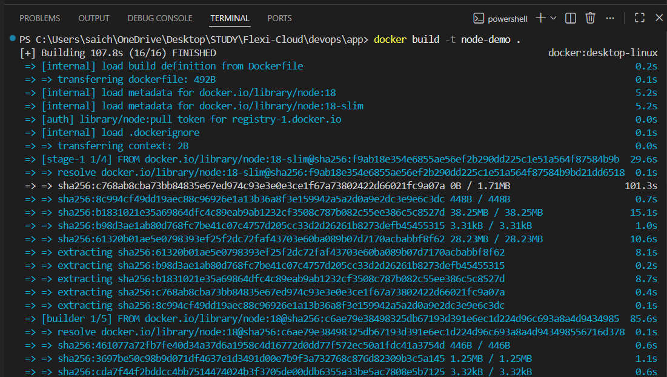
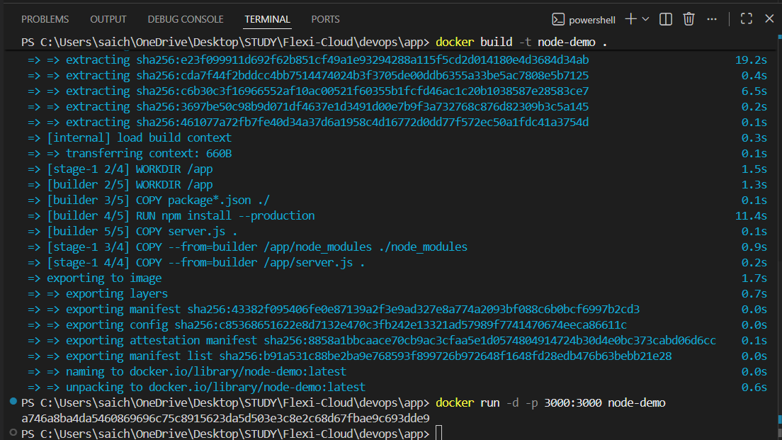

Run Commands

1.Build the docker image named node-demo
docker build -t node-demo .
2.Create the container
docker run -d -p 3000:3000 node-demo
Open Browser type in url : http://localhost:3000/



